Booth Example
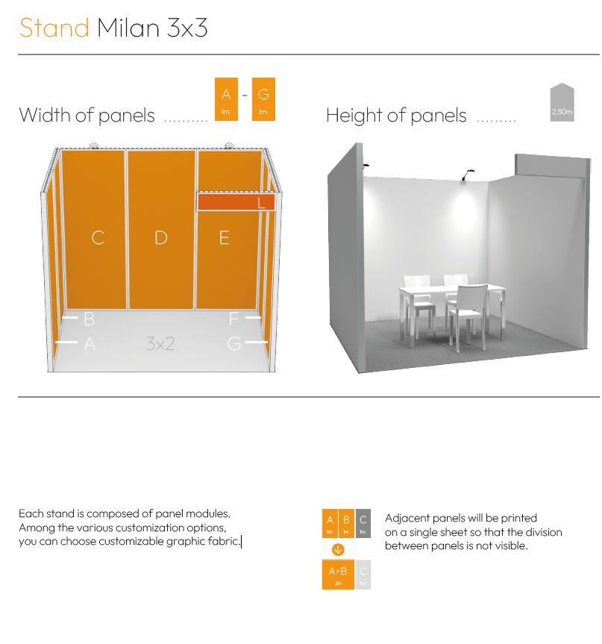
INSTRUCTIONS
The following guidelines are intended to help you create a correct print file.
Print files must meet the following requirements:
1. Color Settings
- Color method: CMYK
- Color profile: FOGRA39
- Black management:
- Rich Black: (Rich Black): C:40 M:30 Y:30 K:100
- Avoid pure black (K:100) for large areas
2. File format
- Accepted formats: PDF or maximum resolution JPG or TIFF
3. Graphic Elements
- Vector Images:
  - Convert all text to outlines
  - Resolve any unintentional overprints
- Raster Images:
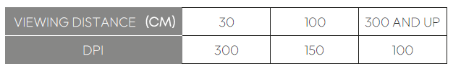
  - Minimum resolution: See the DPI table based on viewing distance

- Embed all images in the document or provide a folder with links
- Avoid lossy compressions (e.g., JPEG) for graphic elements containing text or fine
4. Layout and Dimensions
- Bleed: Minimum 1 cm on all sides
- Scale: Preferably 1:1. If scaled, clearly specify the scale factor and consider the resolution
5. Fonts
- Embedding: All fonts must be fully embedded

6. Quality Control
- It is assumed that those preparing the files should perform a preliminary check
- on the actual size output.
- We reserve the right to check the files and report any anomalies.
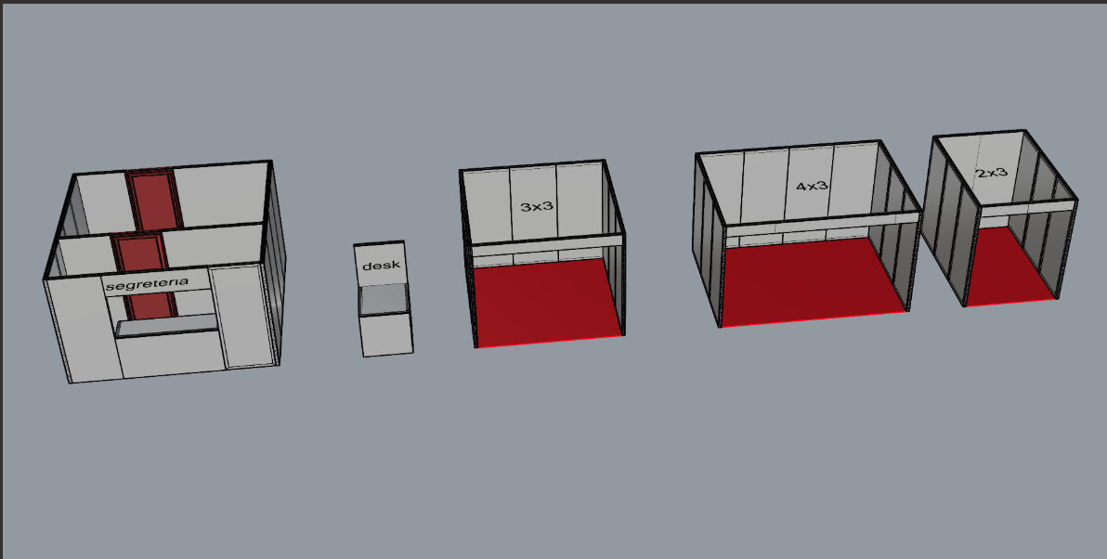

Stands:
The graphic dimensions for the stands will be indicated directly in the online portal. Below are the specifications:
3x4 Stand:
  - Back wall measuring 4x2.5 h.
  - Side walls measuring 3x2.5 h, both with a 1 cm bleed.
  - Front fascia measuring 4x0.25 with a 1 cm bleed.
3x2 Stand:
  - Back wall measuring 2x2.5 h.
  - Side walls measuring 3x2.5 h, both with a 1 cm bleed.
  - Front fascia measuring 2x0.25 with a 1 cm bleed.

