Guide to order from the website:
Upon opening the website, you will see three buttons:
1.Click (here) to open the order website,
2. Click on the stand dimension you have purchased with kenes, if you want to order any BRANDING
3. Click on the exhibition furniture and power image, to order power for your booth and any furniture items.
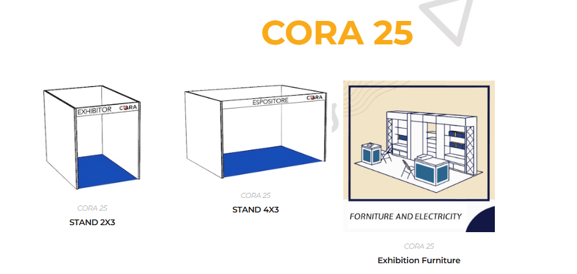
Once you select one of the three options you will have to enter a password. The login password is "cora25".
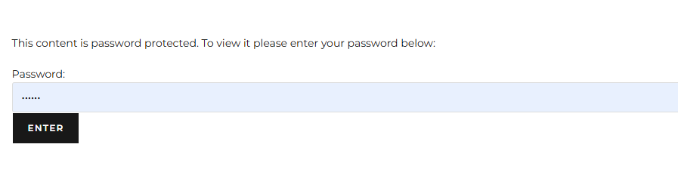
- BRANDING:
Instructions:
- Download the template to insert your artwork in the drive, please rename your file with the company name and booth number: https://drive.google.com/drive/folders/12wOONp0IO7eUrkFnlkChx_zvGldNh28e Stand Template
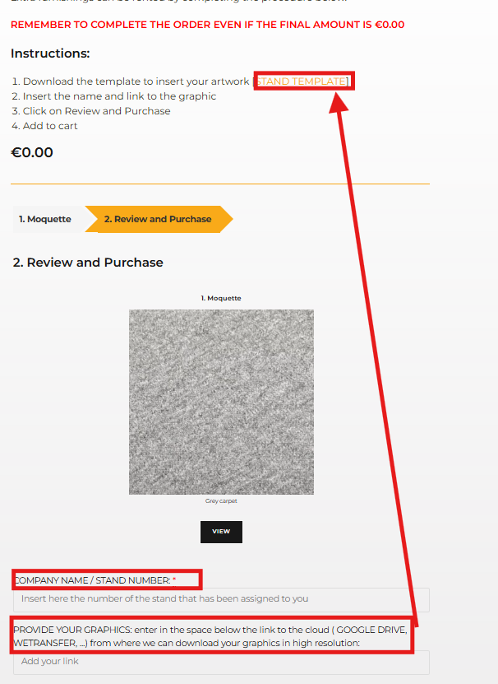
- Click on Review and Purchase.
- Fill your company name and insert the link for your graphics (it should be also upload in the Stand Template drive)
- Add to cart.
- At the top right, click the cart. Remember: Complete the order even if the final amount is €0.00.
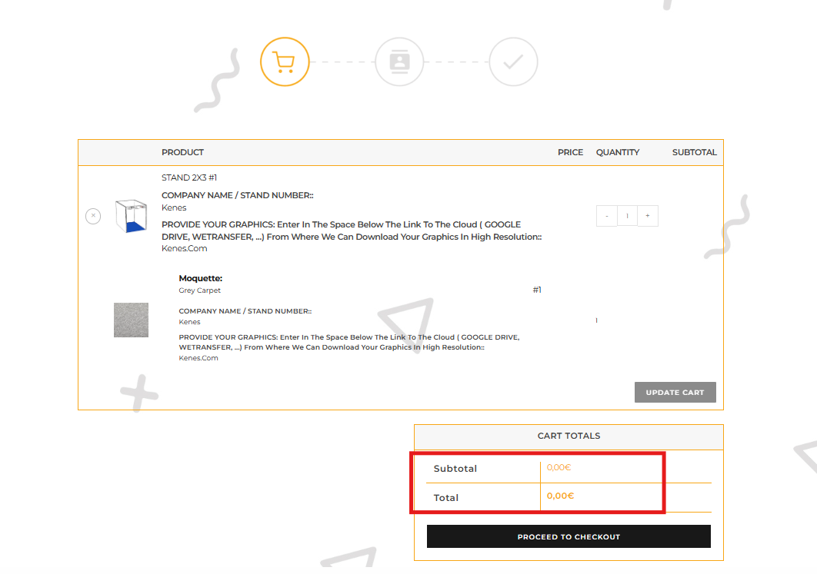

IMPORTANT:
- All prices will appear as €0.00 on the website. After placing the order, you will receive an email with the total cost, as everything is tailored to the exhibitor's needs. You will receive an email with the price and the invoice.
- Deadline for the final artwork must be submitted no later than Friday, February 21st in PDF: February 21st.
2. Furniture and Power:
Prices are already indicated for the furniture items. For electricity you will be contacted for the price for the tailored price.
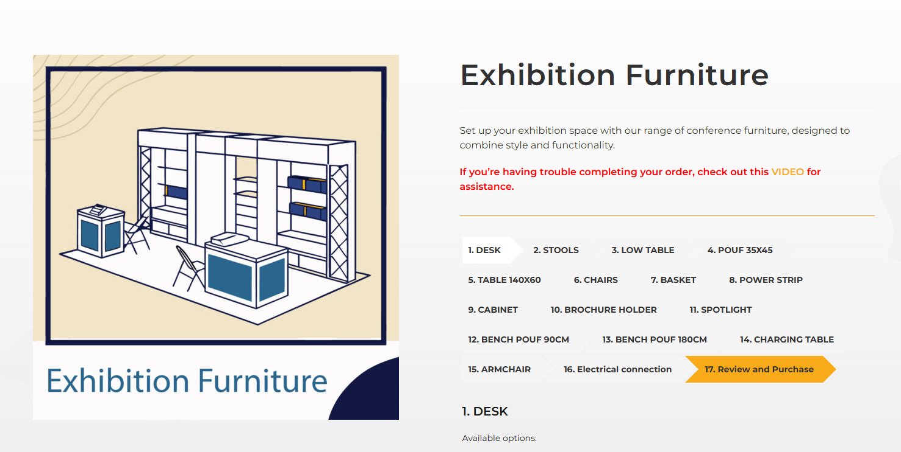
Instructions:
- Choose the product
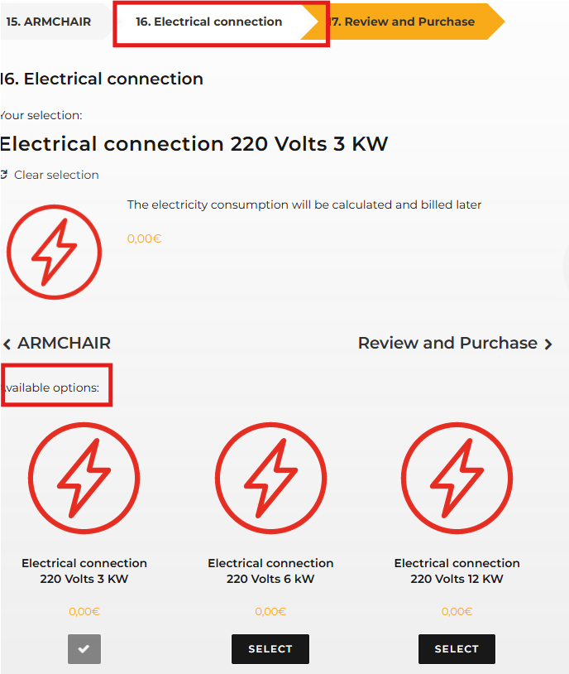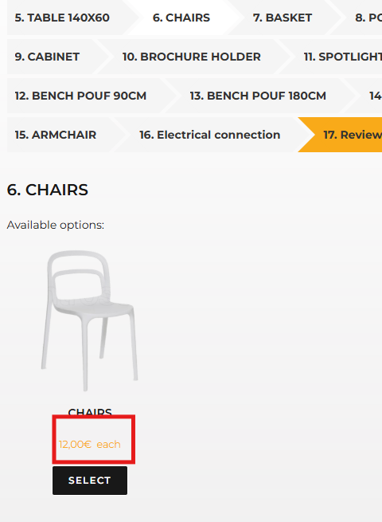

- Please note that for electrical connections will appear as €0.00 on the website. After placing the order, and needs selected you will receive an email with the total cost, as everything is tailored to the exhibitor's needs. You will receive an email with the price and the invoice.

- Place your order and when you finished click Review and Purchase. Type the company name and stand number.
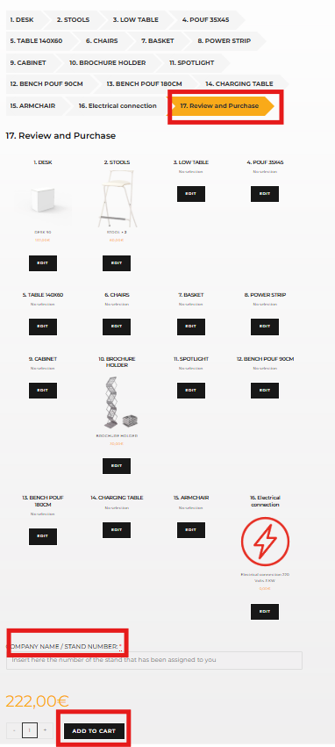
- At the top right, click the cart icon. Remember: Complete the order even if the final amount is €0.00
- Final Check out, fill all the data and proceed, you will receive an email with the final price of the items with 0 cost. You will only pay at the moment the items that have a price.
